CORPORATE TECHNOLOGY SERVICES
Payroll Processing Manual
Employment Hero Payroll · Fortnightly cycle · Complete series
Payroll at CTS runs on a fortnightly cycle. This manual covers that cycle end to end, from collecting payroll notes through to uploading the payment file and filing the records.
The eight parts are also published as standalone guides, so a new starter can be given only the sections that apply to them. Both are generated from the same source, so they always agree.
Reconciliation is split three ways because the rules differ by employment type. Check an employee's type before applying any rule — the same hours are treated differently for a casual and a salaried employee.
Contents
If this page looks empty, Word has not yet built it. Right-click anywhere on it and choose Update Field, or answer Yes when Word offers to update fields on opening.

Part 1 — Payroll Prep
Corporate Technology Services · Employment Hero Payroll · Fortnightly cycle

About this guide
Payroll at CTS runs on a fortnightly cycle. This guide covers Payroll Prep — everything that must be done before a pay run is created. It is the first of a six-part series.
Work through it in order. Every step here must be complete before you move on to Part 2, because a pay run created from incomplete prep has to be scrapped and rebuilt.
Start early. Begin payroll prep on the Friday before the Monday you process payroll. Prep is not a Monday-morning task — leaving it until the day means chasing approvals under time pressure.

Before you begin, make sure you have: Access to the CTS Accounts mailbox, the Y drive (OneDrive), and Employment Hero payroll.

Step 1 Collect payroll notes across the fortnight
Throughout the fortnight you will receive emails covering anything that changes someone's pay. These include:
- Payroll queries
- Backpays — for example, hours worked at the wrong rate, or work not captured on a timesheet
- Additions and bonuses
- Leave approvals and bonus leave
These arrive in one of two places: directly in your own inbox, or in the CTS Accounts inbox. Anything landing in the Accounts inbox is filed under the Payroll category.
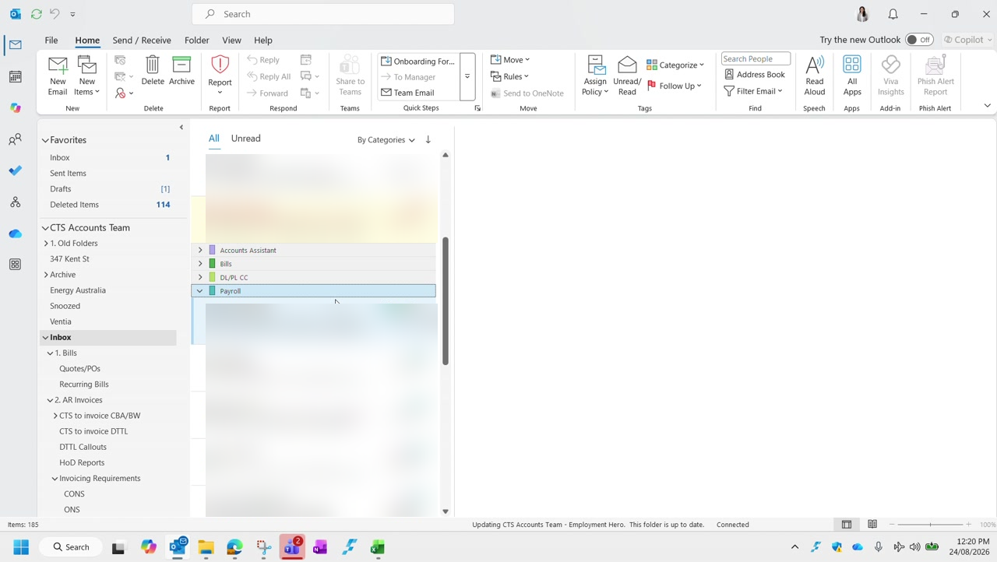
Figure 1 — The CTS Accounts inbox grouped by category. Payroll items are collected under the Payroll category.
Collect as you go. Do not leave this until prep day. Gathering a fortnight of scattered emails in one sitting is where items get missed.

Step 2 Collate the notes into a single email
How you collate the notes is your choice, but the recommended method is to keep them in a single draft email as they arrive.
The reason is the approval step: once prep is finished, the collated notes go to Duncan or Graham for approval. If they are already in an email, that approval is a single send with no rework.
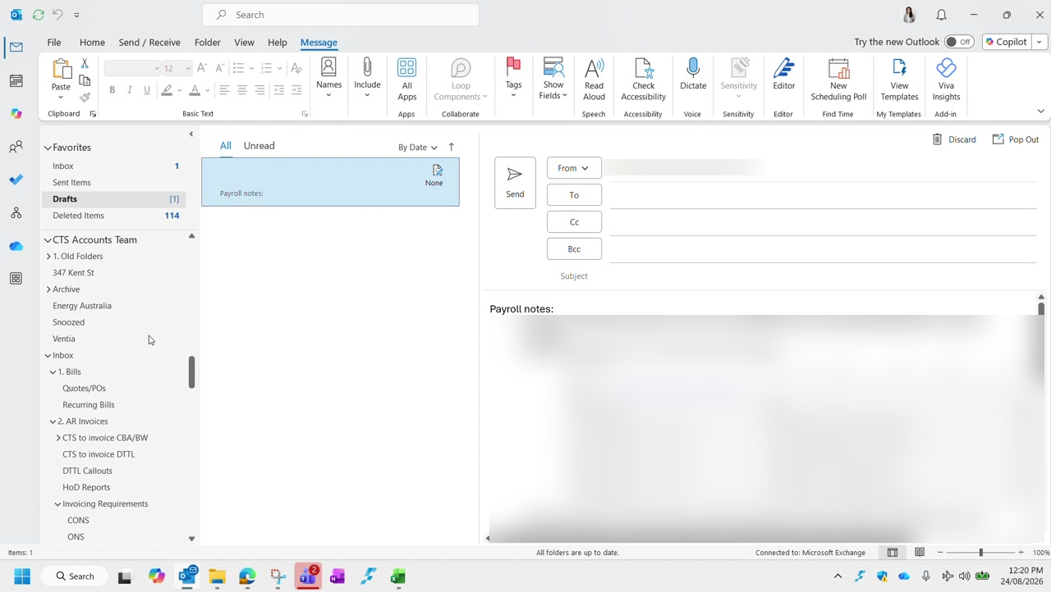
Figure 2 — A running draft of payroll notes. Each item records who is affected, what is owed, and the dates involved. Employee details are blurred in this guide.

Step 3 Copy the timesheet template into the fortnight folder
The timesheet template lives on the Y drive. Navigate to it as follows:
Drive | Y drive — CTS NAS Accounts (Y:) Backup, via OneDrive
Folder | 03 Payroll
Sub-folder | 02 Payroll Related › Payroll Timesheets
Then | The relevant financial year

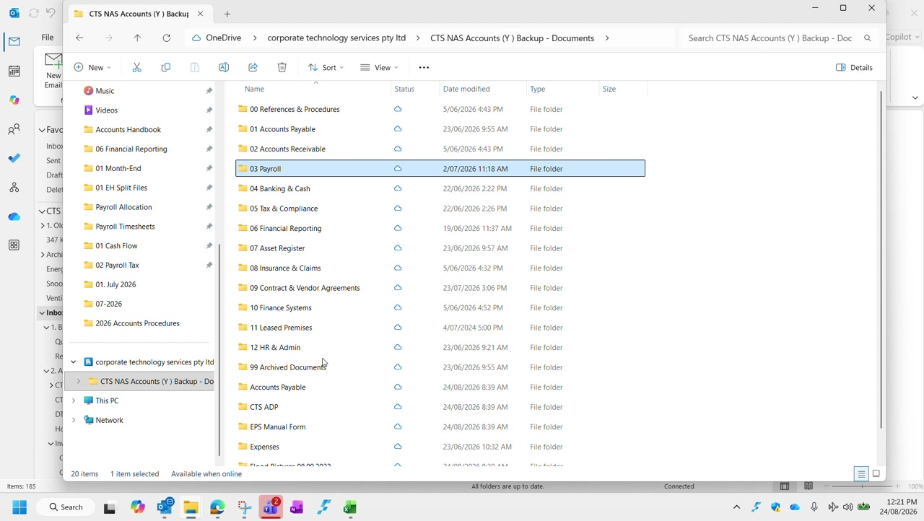
Figure 3 — The Y drive folder structure. Payroll sits under 03 Payroll.
Inside the financial year folder you will find the timesheet template alongside a folder for each fortnight. Copy the template into the correct fortnight folder — do not edit the template itself.
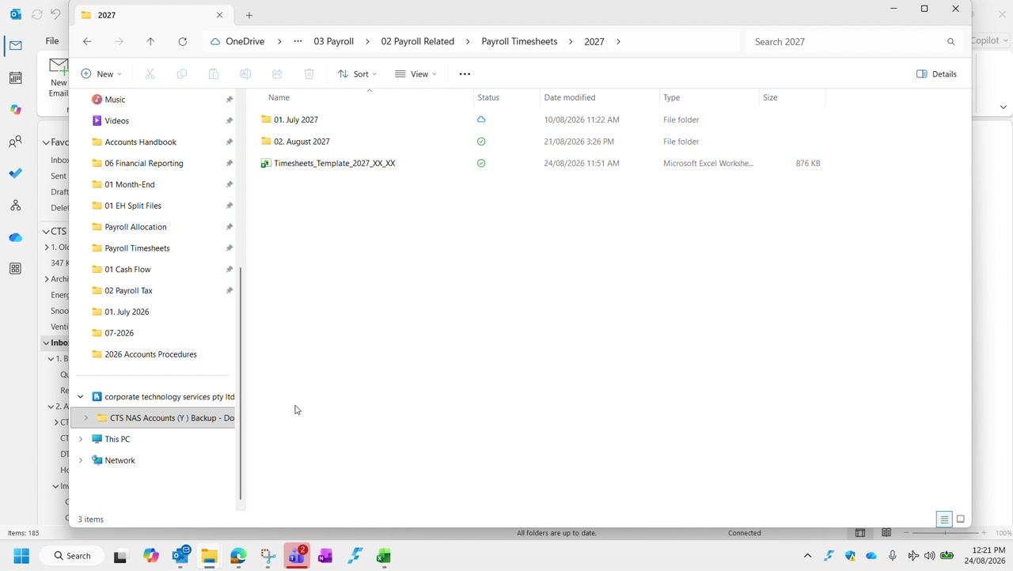
Figure 4 — The financial year folder, containing the fortnight folders and the timesheet template.
Name it for the right fortnight. In the example shown, the fortnight ending is 21 August, covering the period 8 August to 21 August.

Step 4 Populate the timesheet
Transfer each payroll note into your copy of the template. There are two distinct places information goes, and the difference matters.

The Notes section
Every payroll note goes in the Notes section against the relevant employee — regardless of whether it changes their pay. This is the record of what was raised and why.
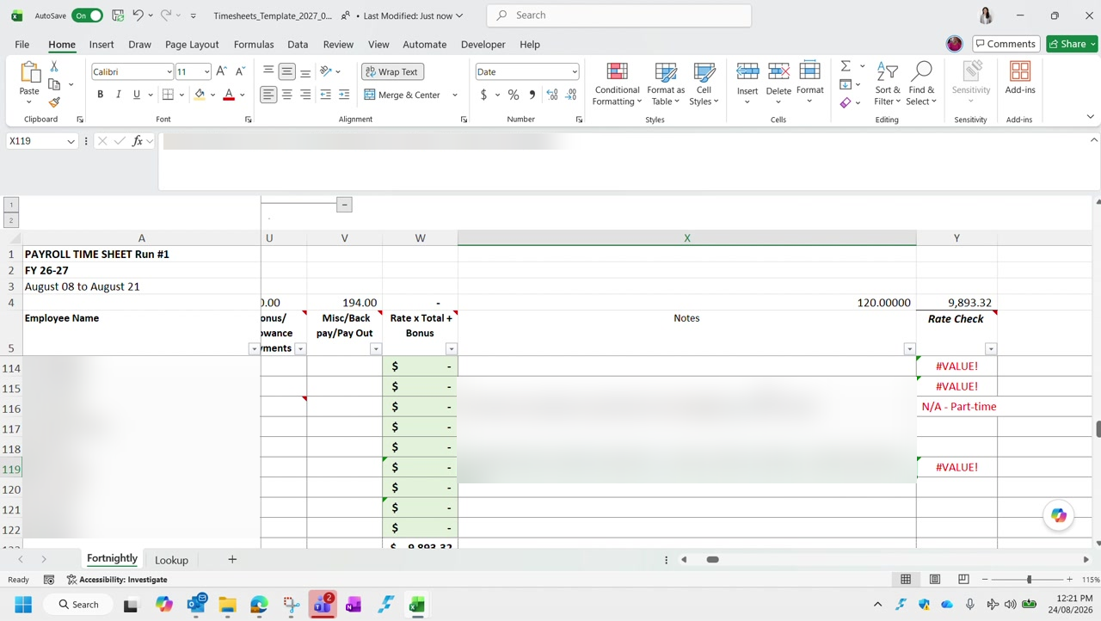
Figure 5 — The Notes column, recording the detail behind each adjustment.

Columns E to S
Columns E through S carry the hours and values that actually drive the pay calculation — Normal Hours, In Lieu Taken, Public Holiday, Annual Leave Hours, and the overtime multipliers T1.25, T1.5 and T1.75.
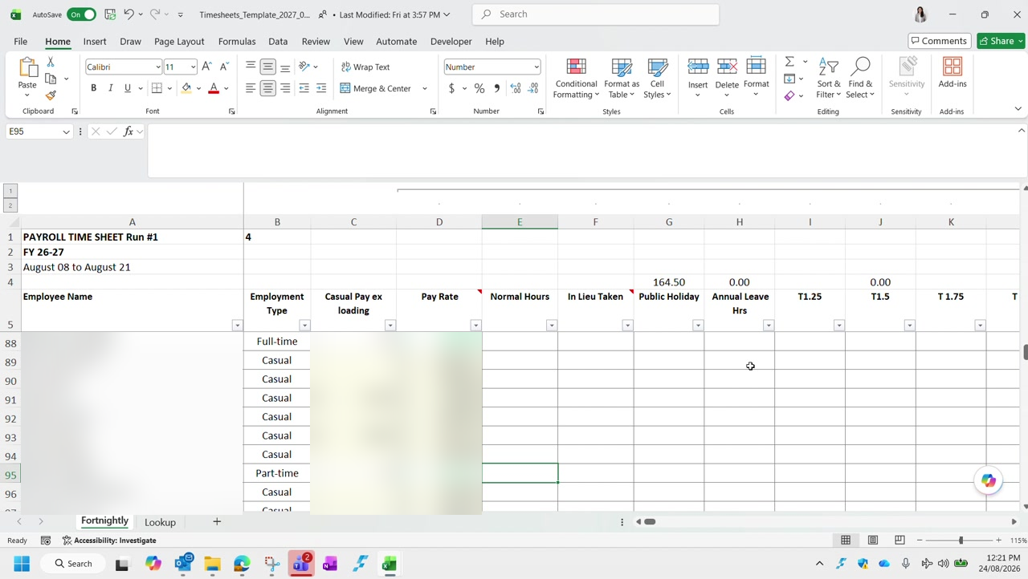
Figure 6 — Columns E to S. Employee names and pay rates are blurred in this guide.
Only if it changes the pay. Populate columns E to S only where the item affects the actual dollar value of the employee's pay. A note that carries no pay impact belongs in the Notes section and nowhere else.

Step 5 Confirm all timesheets are approved in Employment Hero
The last prep step is a gate: you cannot create a pay run while timesheets are still awaiting approval.
In Employment Hero, go to Employee Management › Timesheet Approval, then set the filters:
Show timesheets for period | Fortnight Ending — set to the fortnight you are processing
Status | Submitted

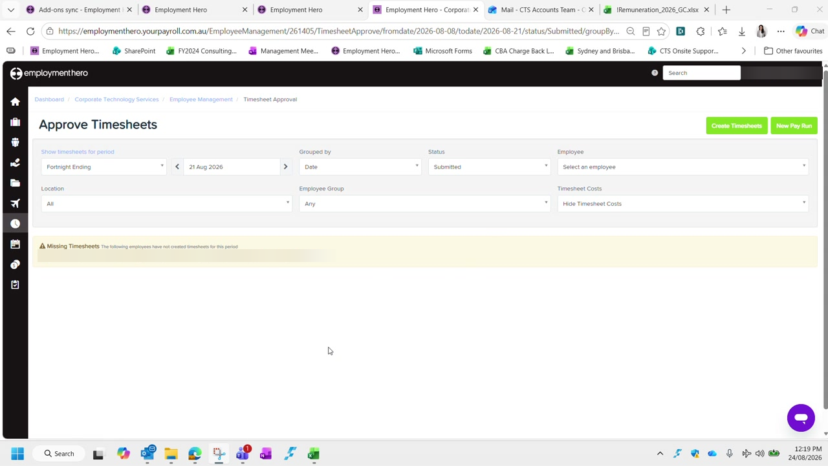
Figure 7 — Approve Timesheets, filtered to Submitted for the fortnight ending 21 August. Employee names are blurred in this guide.
Read the result as follows:
- If timesheets are listed under Submitted, approvals are still outstanding. You cannot start the pay run — chase the approvals first.
- If the list is empty, everything has been approved and you are clear to proceed.
Missing Timesheets is a separate warning. The banner lists employees who have not created a timesheet for the period at all. Follow these up as well — an approved-but-absent timesheet is still a gap in the pay run.

Prep checklist
Payroll prep is complete when all of the following are true:
- All payroll notes for the fortnight have been collected from both inboxes
- The notes are collated in a single email, ready to send to Duncan or Graham for approval
- The timesheet template has been copied into the correct fortnight folder
- Every note is recorded in the Notes section
- Columns E to S are populated for every item that changes the value of pay
- No timesheets remain under Submitted in Employment Hero
- Any missing timesheets have been followed up

Continues in: Part 2 — Creating a New Pay Run.

Part 2 — Creating a New Pay Run
Corporate Technology Services · Employment Hero Payroll · Fortnightly cycle

About this guide
This guide covers creating the fortnightly pay run in Employment Hero. It is the second of a six-part series and picks up directly where Part 1 (Payroll Prep) left off.
Do not start here. Part 1 must be complete first — in particular, every timesheet must be approved. Creating a pay run over unapproved timesheets means deleting it and starting again.

Step 1 Set the fortnight period in the timesheet
Before leaving the spreadsheet, update cell B1 so it reflects the correct fortnight period. This is easy to overlook, and every calculation downstream depends on it.
B1 is a data validation dropdown — click the cell and choose the period number from the list rather than typing a value in.
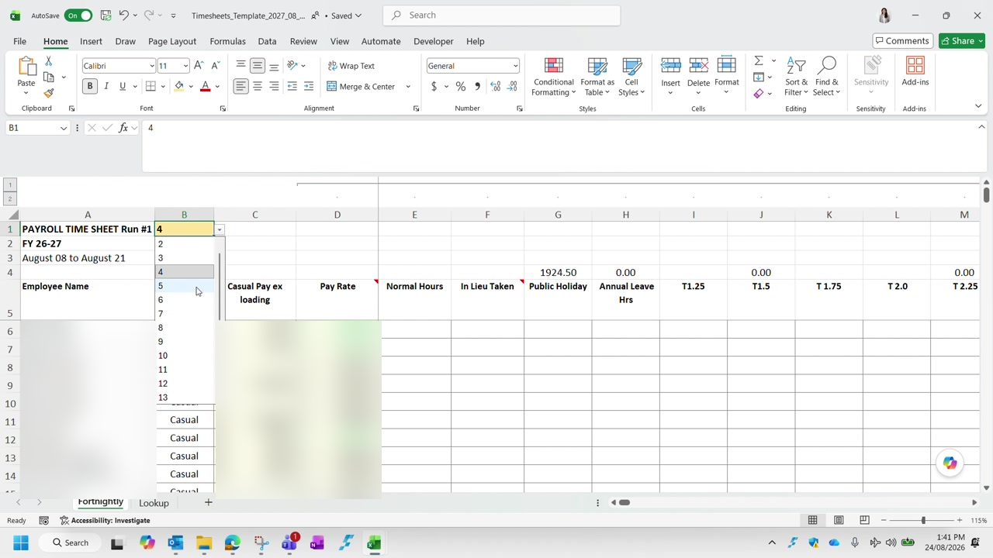
Figure 8 — Cell B1 with its data validation dropdown open. Employee names and pay rates are blurred in this guide.
The dropdown values come from the Lookup tab, which lists every pay period in the financial year along with its start and end dates. If you are unsure which period number applies, check the dates there.
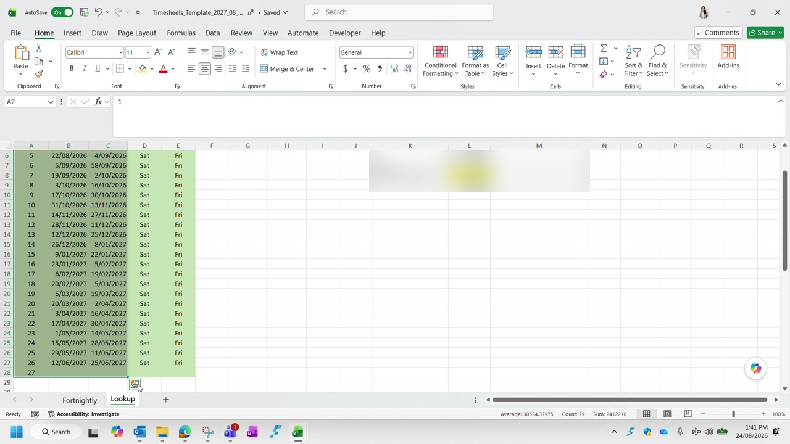
Figure 9 — The Lookup tab, listing the pay periods for the financial year.

Step 2 Re-confirm that no timesheets are pending
As covered in Part 1, check Employment Hero one more time before creating the pay run. Filter Approve Timesheets to the fortnight you are processing with Status set to Submitted.
Nothing under Submitted. If anything is still listed there, approvals are outstanding and you cannot proceed. An empty list means everything is approved and you are clear to continue.

Step 3 Create the pay run
In Employment Hero, go to Pay Runs and choose to create a new pay run. Most of the form pre-fills, but three fields need checking and one needs real care.
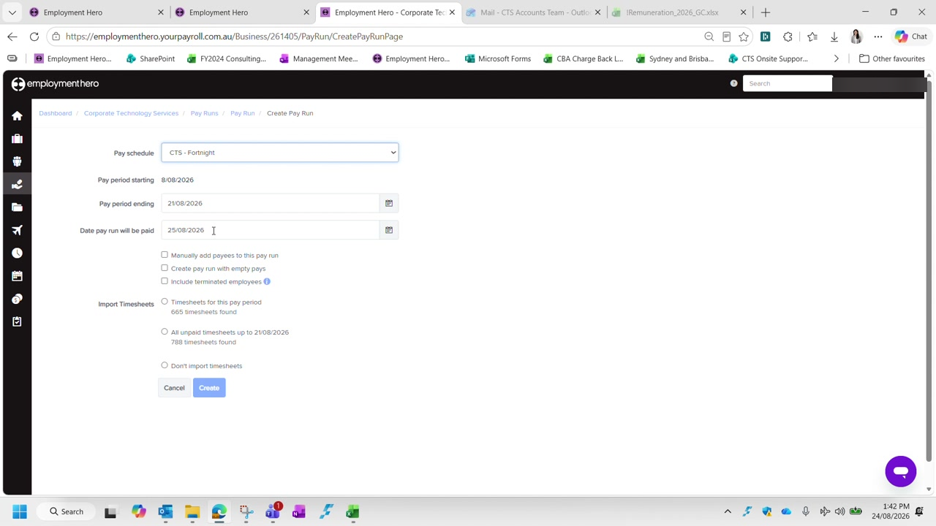
Figure 10 — The Create Pay Run screen. Note the two import options and the difference in timesheet counts.
Pay schedule | CTS - Fortnight
Pay period starting | Pre-filled — confirm it matches your fortnight (8/08/2026 in the example)
Pay period ending | Pre-filled — confirm it matches your fortnight (21/08/2026 in the example)
Date pay run will be paid | Always the Tuesday of the payroll processing week (25/08/2026 in the example)
Import Timesheets | Always the first option — Timesheets for this pay period

The import option is the one to get right. Choose Timesheets for this pay period, never All unpaid timesheets. The second option sweeps up unpaid timesheets from outside the fortnight, which pulls the wrong periods into your pay run. In the example the difference is 665 timesheets versus 788 — 123 that do not belong.

Leave the three checkboxes (Manually add payees, Create pay run with empty pays, Include terminated employees) unticked unless you have a specific reason. Then click Create.
Employment Hero takes a few moments to perform its calculations — the wait is normal and scales with the size of the pay run.

Step 4 Check the pay run has been created correctly
When it finishes you land on the pay run itself, showing every payee with their hours, earnings, deductions, withheld amounts, super contributions and net pay.
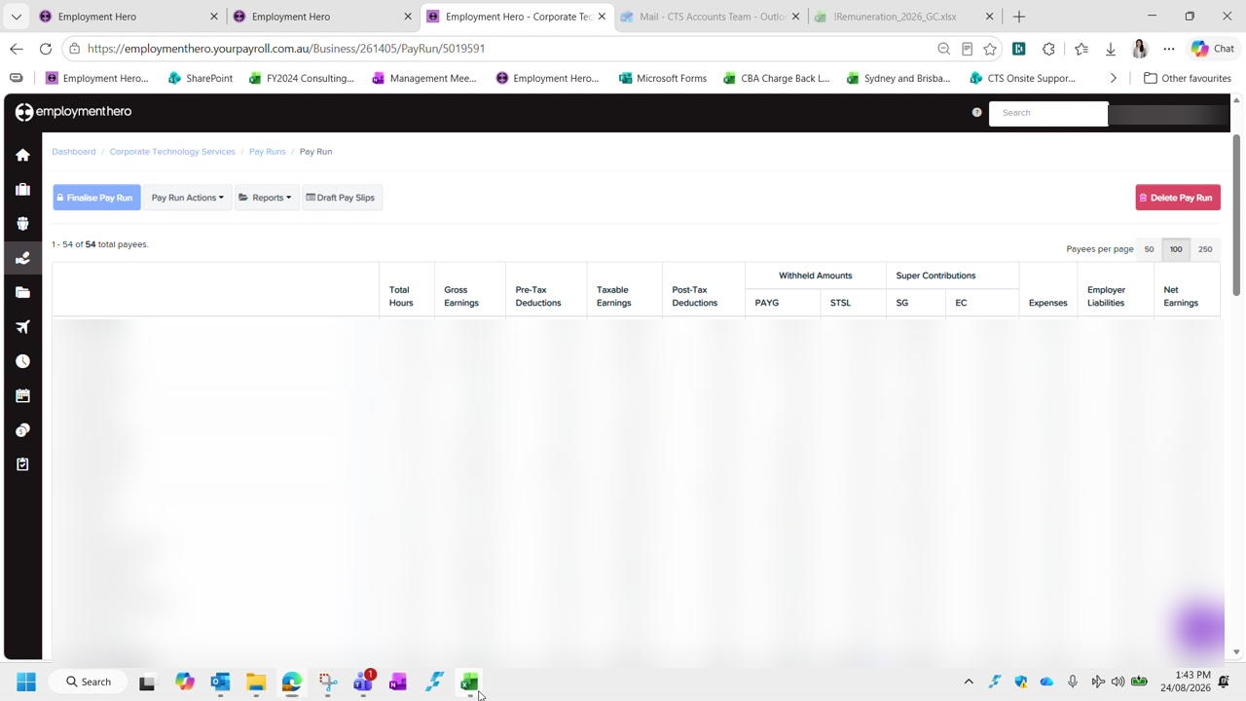
Figure 11 — A created pay run. Employee names and all pay figures are blurred in this guide.
Check the payee count at the top left before going further — it reads 1 - 54 of 54 total payees in the example. If that number looks wrong for the fortnight, stop and investigate rather than working through the pay run.
You can start over. Nothing is committed at this stage. If the pay run was created with the wrong period or the wrong import option, use Delete Pay Run and create it again. That is far quicker than correcting it employee by employee.

Checklist
The pay run is correctly created when all of the following are true:
- Cell B1 in the timesheet reflects the correct fortnight period
- Nothing remains under Submitted in Approve Timesheets
- The pay schedule is CTS - Fortnight
- The pay period start and end dates match the fortnight being processed
- The pay date is the Tuesday of the processing week
- Timesheets for this pay period was selected — not All unpaid timesheets
- The total payee count looks correct for the fortnight

Continues in: Part 3a — Reconciling Casual Timesheets, the first of three guides covering reconciliation. Parts 3b and 3c cover salaried staff and the cases needing manual handling.

Part 3a — Reconciling Casual Timesheets
Corporate Technology Services · Employment Hero Payroll · Live Performance Award

About this guide
Reconciling timesheets is the longest stage of the fortnight. It is covered by three guides, because the rules differ sharply depending on who you are looking at:
- Part 3a (this guide) — casual employees, governed by the Live Performance Award
- Part 3b — salaried and full-time employees, governed by the internal CTS Overtime Matrix
- Part 3c — employees needing manual handling, including part-timers who do not clock in
Work through the pay run in alphabetical order and pick up whichever guide applies to the employee in front of you. Check the Employment Type column before applying any rule — the same hours are treated differently for a casual and a salaried employee.
The award is the authority. Casual entitlements come from the Live Performance Award, not from what Employment Hero calculates. Employment Hero gets it wrong often enough that you must check rather than assume. Keep the award open in a tab while you work.

Where the information comes from
Three sources between them tell you what an employee actually worked:
Shared calendar | What was scheduled across the business for the fortnight
Approved timesheets | A snapshot of total hours per employee for the fortnight
Rostering | Each team's roster — Production, Banquet, CBA support and Deloitte support each keep their own

In the rostering view, group by business and hide employees with no shifts. That tells you who was rostered for the period and lets you verify the times they actually logged.
Ad hoc contracts have no roster. Some contracts — PwC Australia and payment networks among them — do not run a roster at all. For those employees the timesheets are the only source, and the hours are verified by the approving manager instead.

Step 1 Compare the timesheet against the roster
Open the employee's timesheets for the fortnight and use Compare with roster. Employment Hero then shows the rostered line directly beneath the actual line for each shift.
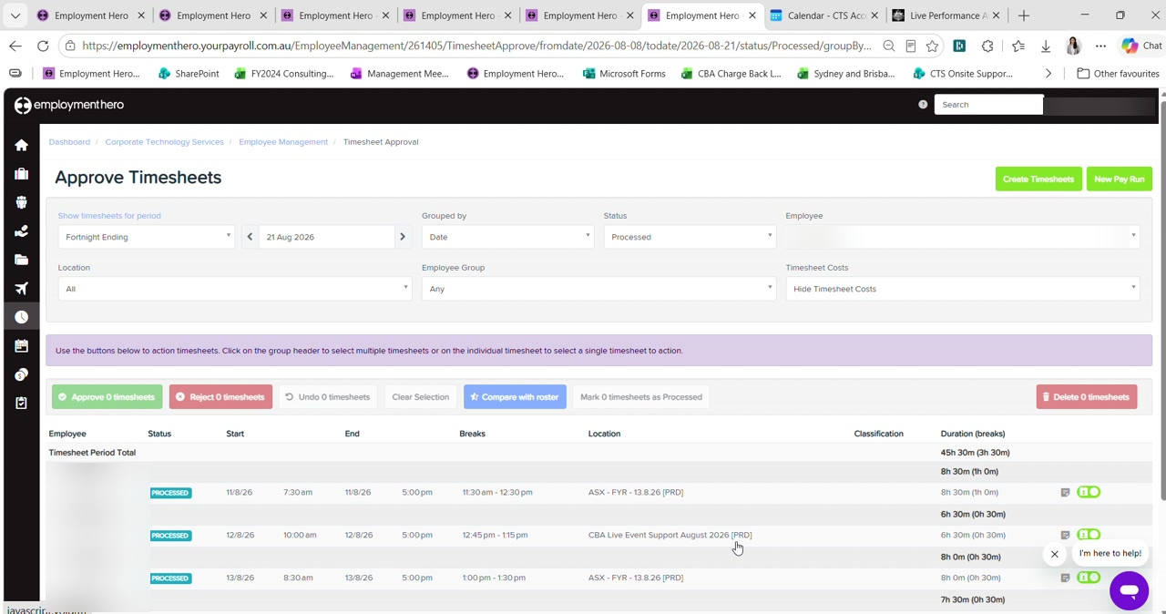
Figure 12 — Approve Timesheets for a single employee, with Compare with roster available. Employee names are blurred in this guide.
Read the result as follows:
- A tick on the left means the rostered and actual times reconcile — nothing to do
- A warning sign means there is a difference, and the view highlights exactly what differs
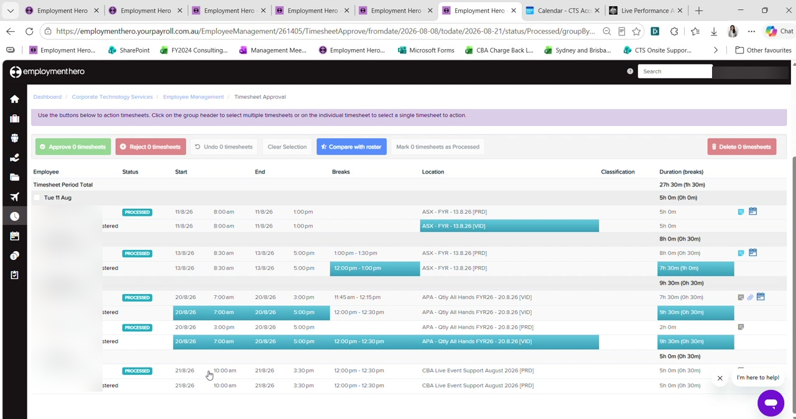
Figure 13 — The comparison view with differences highlighted against the rostered line. Employee names are blurred in this guide.
Most differences are one of two kinds, and neither is a problem in itself:
Break length | Rostered for an hour, took half an hour. Common and expected.
Cost centre | Worked across two cost centres rather than the one rostered — for example moving from one event to another mid-shift.

Cost centre splits do not matter here. The production manager splits shifts by where the person actually worked, and will have checked it before approving. What you are verifying is that the total hours reconcile — if they were rostered 7 to 4, the actual hours should also come to 7 to 4.

Step 2 Check for weekly overtime above 38 hours
Under the Live Performance Award, a casual working more than 38 hours in a week attracts overtime on the excess, paid at 1.75. The award sets this out at clause 63.
Look at the fortnight one week at a time — the threshold is weekly, not fortnightly. A casual can work 41 hours in the first week and 32 in the second and still be owed overtime on the first week's three hours.
Employment Hero does not always catch this. It sometimes captures the overtime automatically and sometimes does not, with no obvious reason for the difference. Always check the weekly totals yourself rather than trusting the pay run.

To correct it, use Actions › Add earnings and choose the casual overtime category at 1.75. Copy the notes from the row above so the record stays consistent, then reduce the ordinary hours by the same amount.
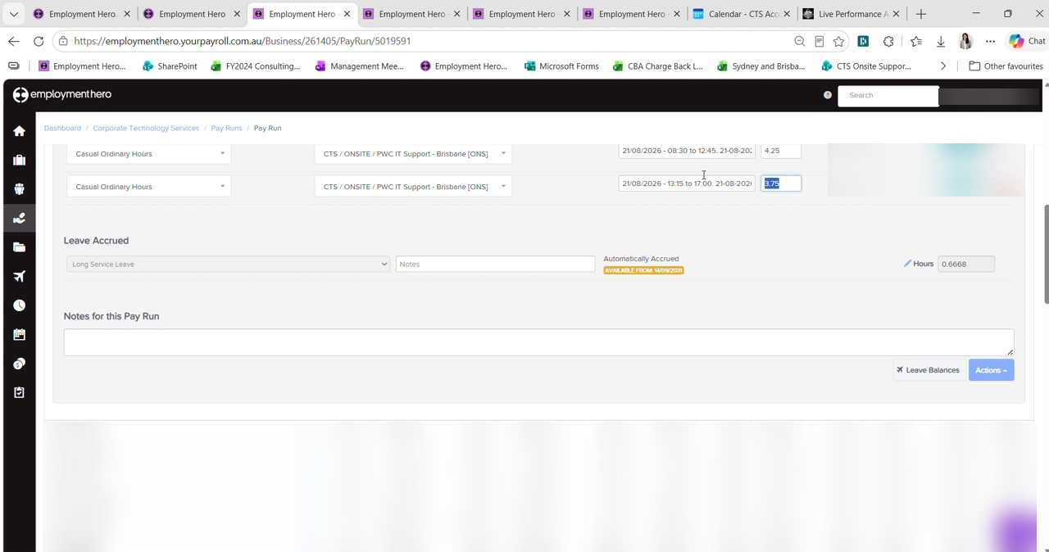
Figure 14 — Casual Ordinary Hours rows in the pay run, with the Leave Accrued and Notes sections beneath. Rates and amounts are blurred in this guide.
The total must not change. You are re-splitting hours, not adding them. Forty hours becomes 38 at ordinary plus 2 at 1.75 — the total stays at 40. If your total moves, something is wrong.

Step 3 Check for daily overtime above 8 hours
Separately from the weekly threshold, anything worked beyond eight hours in a single day is overtime. Work through the days that run long and check each one against the timesheet.
Where a manager has approved overtime there will be an attachment on the timesheet. Open it — under the current overtime procedure the manager must record why the overtime was approved, whether it is chargeable to a client, and whether it is being paid as time in lieu or at a penalty rate.
Read the attachment carefully. The attachment tells you which portion of the shift is overtime, not the whole shift. If someone was rostered 7 to 5 and worked 7 to 5, the first eight hours are still ordinary hours and only the excess attracts the penalty.

Step 4 Do not pay both daily and weekly overtime
Employment Hero will sometimes trigger overtime twice for the same hours — once for a day over eight hours, and again for the week exceeding 38.
Pay one, not both. The award does not require both to be paid for the same hours. Choose either the daily or the weekly calculation and delete the other. Paying both is double-dipping and overpays the employee.

After deleting the duplicate, confirm the total hours still match what the employee actually worked.

Step 5 Check meal breaks
This is the rule that causes the most trouble, and it has two distinct thresholds.
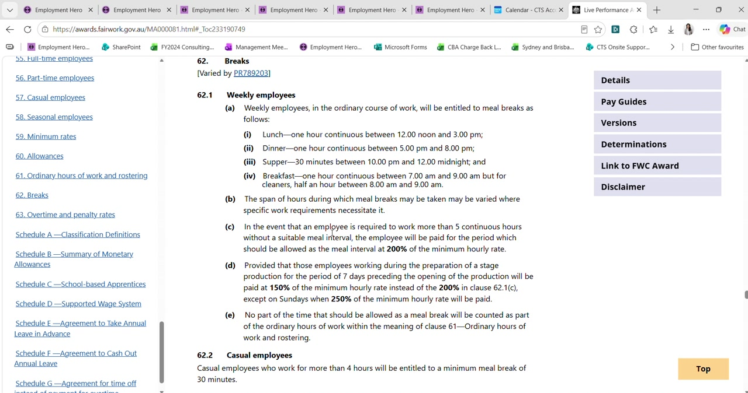
Figure 15 — Live Performance Award clause 62, setting out the break entitlements for weekly and casual employees.
More than 4 hours | Entitled to a minimum meal break of 30 minutes (clause 62.2)
More than 5 continuous hours with no suitable break | The period that should have been the meal interval is paid at 200% of the minimum hourly rate (clause 62.1c)

Employment Hero silently removes the half hour. If a casual works more than four hours and no meal break is recorded, Employment Hero deducts 30 minutes automatically. The employee worked that time and must be paid for it — so the shift will be short unless you correct it.

The fix is to set the work type on the timesheet, not to add half an hour to the pay run. Setting the work type makes the record accurate and lets Employment Hero apply the right treatment:
- Exclude the employee from the pay run
- Go to Approved timesheets and Undo the affected timesheet — only the shift that needs editing
- Change its status back to Submitted, then edit it
- Set the Work Type to Working During Meal Break
- Approve the timesheet again and add the employee back to the pay run
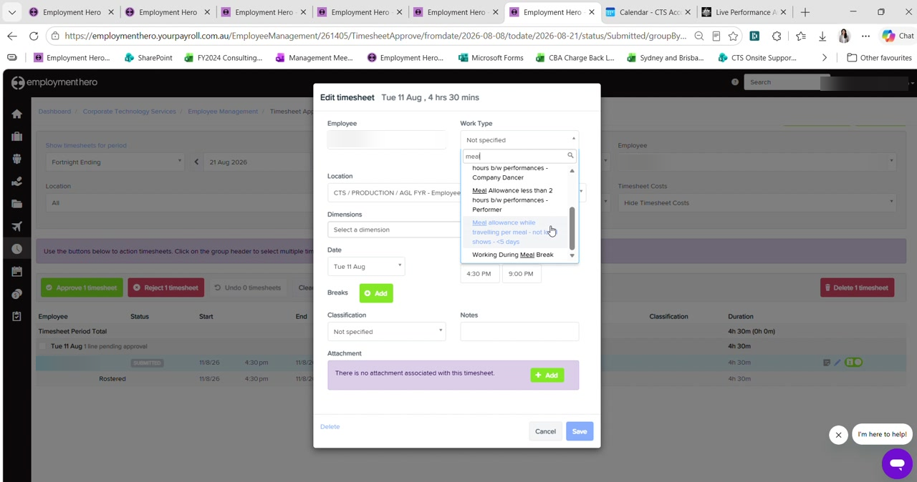
Figure 16 — Editing a timesheet and searching the Work Type list for the meal break categories. Names and locations are blurred in this guide.
The work type does not mean the whole shift. Setting Working During Meal Break does not pay the entire shift at a penalty. It captures the half hour that would otherwise have been removed. Its real importance is on longer shifts — past five hours the award's 200% provision applies, and without the work type Employment Hero will not calculate it.

So the same missing break produces different outcomes depending on shift length. A four-and-a-half hour shift simply recovers its half hour. A six-hour shift crosses the five-hour threshold and attracts the penalty as well.

Step 6 Update the spreadsheet
Once the pay run is right for that employee, transfer the result into the timesheet spreadsheet — ordinary hours in Normal Hours, and any overtime into the matching multiplier column.
Mark a pay rate green once you have verified it. Green means checked this fortnight, so anything left unhighlighted still needs looking at when you verify rates in Part 5.

Checklist
For each casual employee:
- Timesheets compared against the roster, and any differences understood
- Each week checked separately for hours above 38
- Each day checked for hours above eight, with the manager's attachment read where present
- No hours paid at both daily and weekly overtime
- Missing meal breaks corrected using the work type, not a manual adjustment
- Total hours unchanged by any re-split of ordinary and overtime
- Hours transferred to the spreadsheet and the rate marked green once verified

Continues in: Part 3b — Reconciling Salaried & Full-Time Timesheets.

Part 3b — Reconciling Salaried & Full-Time Timesheets
Corporate Technology Services · Employment Hero Payroll · CTS Overtime Matrix

About this guide
This guide covers salaried and full-time employees. It is the second of the three reconciliation guides — Part 3a covers casuals, and Part 3c covers employees who need manual handling.
Different rules entirely. Full-time and salaried staff are not treated under the Live Performance Award. CTS pays above award and applies its own overtime matrix instead. Applying casual award rules to a salaried employee will produce the wrong pay.

Step 1 Start from the 80-hour rule
A full-time employee's fortnight should come to exactly 80 hours, unless there is approved overtime that has been pre-approved by their manager.
That figure is the anchor for everything else in this guide. If the total is not 80, something needs finding — and it is usually the rounding rule below rather than a genuine shortfall.

Step 2 Understand the 8-hour rounding rule
There is a preset rule in the Employment Hero back end that caps each salaried employee's captured hours at eight per day. It was created when CTS migrated from ADP to Employment Hero and applies to salaried employees only.
It rounds in both directions. The rule does not simply cap long days. It also rounds short days up. If someone works less than eight hours on a day, Employment Hero will still record eight. This is the single biggest source of confusion when a total does not reconcile.

The practical consequence is that the pay run total and the real timesheet total can differ even when nothing is wrong. So you cannot reconcile from the pay run alone — you have to open the timesheets and compare day by day.
Work through the days that ran longer than eight hours and check what the pay run actually captured for each. Where it captured eight and the timesheet shows more, add the difference back.
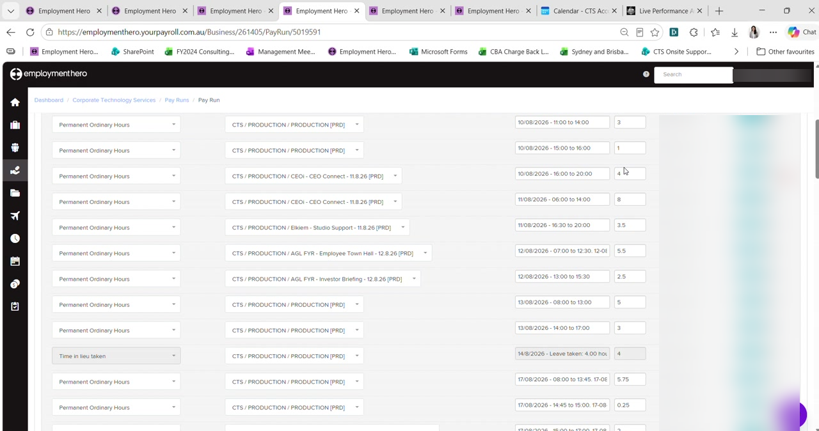
Figure 17 — Permanent Ordinary Hours rows for a salaried employee, including a Time in lieu taken row. Rates and amounts are blurred in this guide.
Managers sometimes balance days themselves. A manager may deliberately put four hours over on one day and four hours under on another so the fortnight still comes to 80. Before chasing a shortfall, check the week-ending view to see whether it has already been balanced out elsewhere in the fortnight.

Step 3 Apply the CTS Overtime Matrix
Where overtime is genuinely payable, the rate comes from the internal CTS Overtime Matrix rather than the award. The matrix is held in the HR Resource Library on SharePoint.
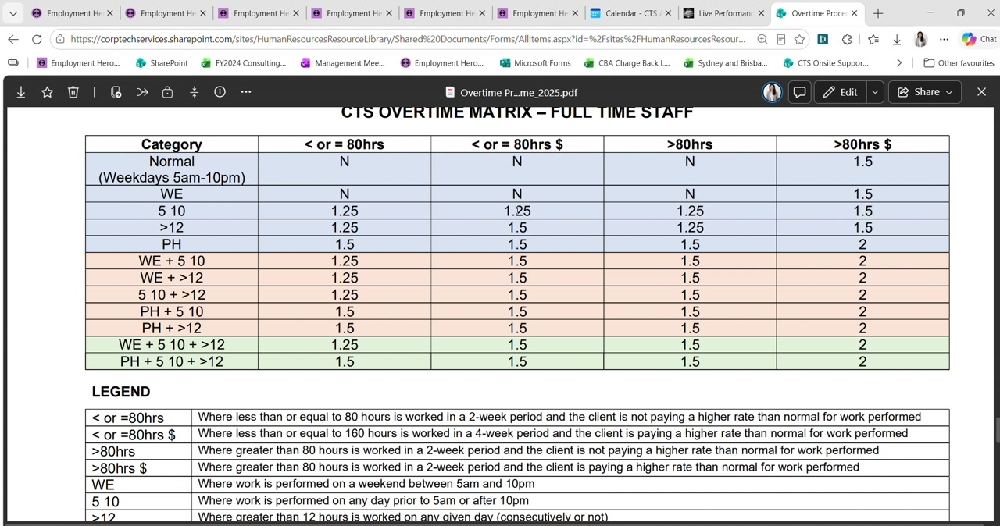
Figure 18 — The CTS Overtime Matrix for full-time staff, with its legend.
Reading the matrix takes two pieces of information — which row the shift falls into, and which column applies to the fortnight:
Row | The nature of the shift: normal weekday, weekend (WE), before 5am or after 10pm (5 10), more than 12 hours in a day (>12), public holiday (PH), or a combination
Column | Whether the fortnight is at or under 80 hours or above it, and whether the client is paying a higher rate than normal for the work
The $ columns | Mean the work is chargeable to the client at a higher rate — not simply that money is involved

So a shift worked between 10pm and 10:45pm, in a fortnight within 80 hours, chargeable to the client, falls in the 5 10 row against the chargeable column — giving 1.25.
To apply it, use Actions › Add earnings and pick the matching category, such as permanent overtime at 1.25. Copy across the notes so the reason is recorded against the entry.

Step 4 Record time in lieu taken
Time in lieu taken is a form of leave, and must be populated in the In Lieu Taken column of the spreadsheet rather than left in ordinary hours.
The rest calculates itself. Once you populate the leave columns, the remaining ordinary hours follow automatically — the formula takes 80 hours and subtracts whatever you have entered across columns F to S. Do not type the ordinary hours in by hand.

Where an employee accrues and takes time in lieu within the same fortnight and the two cancel out, the totals will still reconcile. Even so, record it properly and add a note explaining the offset, so that someone reading the fortnight later can see what happened.

Step 5 Check pay run inclusions
Salaried employees often carry standing arrangements set up in their employee profile under pay run inclusions — most commonly a pre-tax salary sacrifice for technology, or a superannuation salary sacrifice.
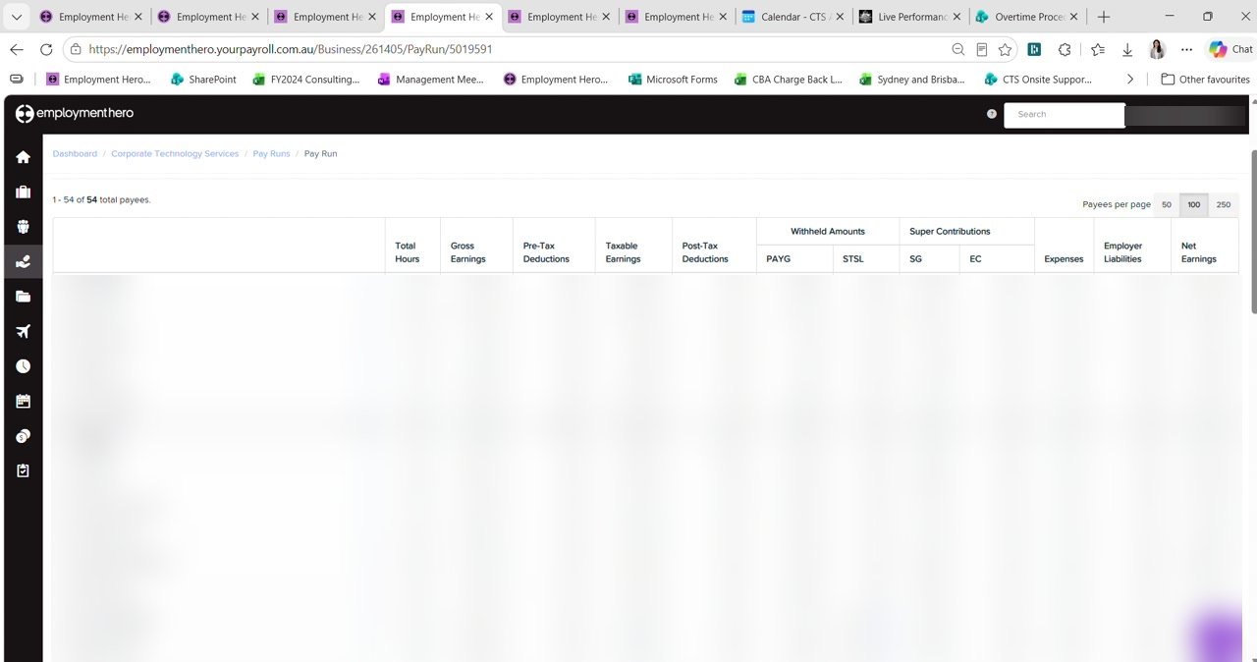
Figure 19 — The pay run employee list, from which each employee's detail is opened. Names and pay figures are blurred in this guide.
These deduct automatically each fortnight and stop on their own, so they need checking rather than adjusting. There are two ways they can be set to end:
By amount | The deduction stops once the nominated total has been reached. Preferred for technology salary sacrifice.
By date | The deduction stops on a set date. Preferred for superannuation salary sacrifice.

Check it is still within its nominated period. An arrangement that has passed its end date but is still active will keep deducting. Confirm against what the employee set out on their nominated form.

Step 6 Apply any back pay from the payroll notes
Where the payroll notes from Part 1 record a back pay for this employee, add it now using Actions › Add earnings with the category the overtime matrix gives you, and copy the note across so the reason travels with the entry.
Record the same back pay in the spreadsheet against the employee, in the back pay column on the right.

Checklist
For each salaried or full-time employee:
- The fortnight reconciles to 80 hours, or the excess is approved overtime
- Days over eight hours checked against the timesheet, not just the pay run
- Short days checked for the rounding rule rounding them up to eight
- The week-ending view checked before chasing an apparent shortfall
- Any overtime rated from the CTS Overtime Matrix, not the award
- Time in lieu taken recorded in the leave column, with ordinary hours left to the formula
- Pay run inclusions still within their nominated amount or date
- Any back pay from the payroll notes added and recorded in the spreadsheet

Continues in: Part 3c — Employees Needing Manual Handling.

Part 3c — Employees Needing Manual Handling
Corporate Technology Services · Employment Hero Payroll & HR · Exception cases

About this guide
Parts 3a and 3b cover employees whose hours flow into the pay run on their own. This guide covers the ones that do not — people who are missing from the pay run entirely, or whose hours cannot be taken at face value.
These are easy to miss. Everyone in Parts 3a and 3b appears in the pay run, so working through it top to bottom finds them. The employees in this guide can be absent altogether. Nothing prompts you — you have to know to look.

Step 1 Part-time employees who do not clock in
Some part-time employees do not clock in and out at all. Instead there is a rule against their login setting fixed hours for the fortnight — 40 hours rather than a full-timer's 80.
Because there are no timesheets, they are not picked up when the pay run imports timesheets, and they will not appear in it. Add them manually:
- In the pay run, go to Pay Run Actions › Add payees
- Type the employee's name and select them
- Their fixed hours populate automatically from the rule on their login
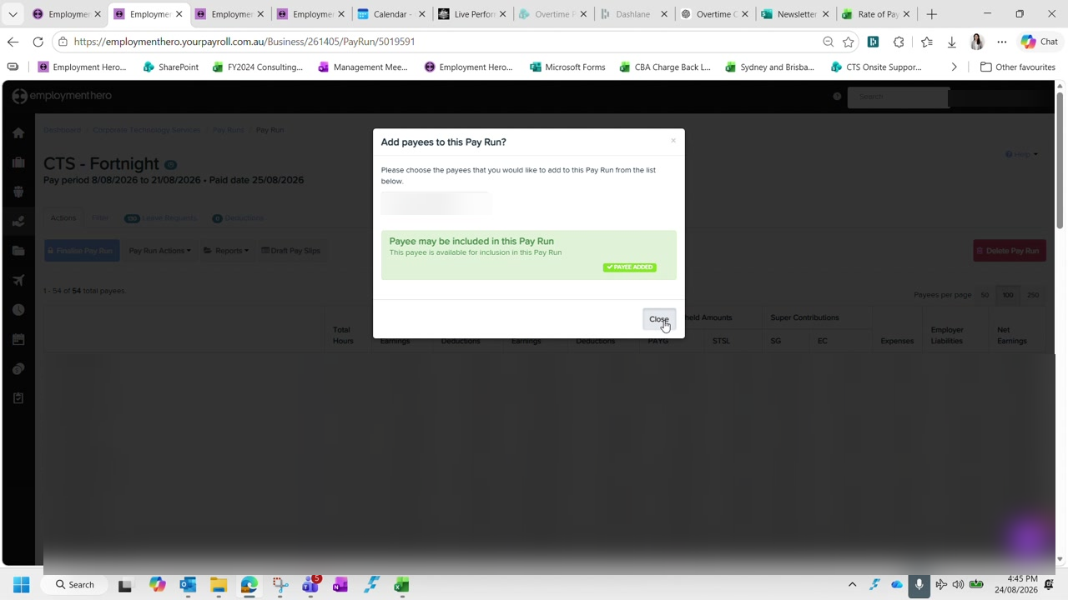
Figure 20 — Adding a payee to the pay run, with the confirmation that the payee has been added. Names and pay figures are blurred in this guide.
Always check the rate. The hours populate automatically but the rate does not always come through correctly. Verify it against the employee's profile before moving on — this is a recurring problem, not a one-off.

Step 2 New starters
A new starter will appear in the pay run, because they have timesheets, but they will not be in the timesheet spreadsheet — it was copied from a template created before they joined.
Add them into the spreadsheet in alphabetical position, with their hourly rate taken from their contract.
Use the ex-loading rate. For casual new starters, the rate in the spreadsheet is the rate excluding casual loading. A contract quoting a rate inclusive of loading needs converting before it goes in, or every calculation downstream will be overstated.

Step 3 Employees with no timesheets this fortnight
Occasionally someone worked a shift that was never captured — they did not clock in, so there was no timesheet, so they are not in the pay run at all. These usually surface when the employee emails about a missed pay.
The shift may belong to an earlier fortnight. That is still handled in the current pay run:
- Pay Run Actions › Add payees, and add the employee
- Import timesheets, choosing the option that covers unpaid timesheets rather than this pay period
- Select only the shifts that belong to the period being corrected
- Delete anything else the import brings in
This is the one time you use the second import option. Part 2 warns you to always import Timesheets for this pay period. This is the exception — recovering a missed shift needs the unpaid timesheets option. Delete every row it brings in except the ones you are correcting, and check the employee's total afterwards.

Step 4 Leave without pay
Leave without pay cannot be entered in payroll directly. It is created in Employment Hero HR and then synced across, so it has to be done in the right order.
First, exclude the employee from the pay run. Then in Employment Hero HR, go to Time & Leave Management and create a leave request on their behalf:
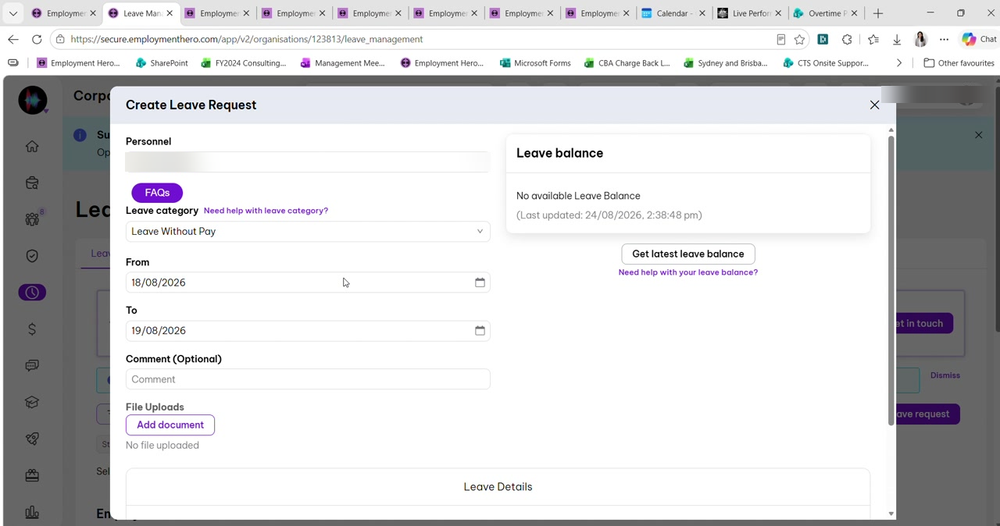
Figure 21 — Creating a leave request on an employee's behalf in Employment Hero HR, with the category set to Leave Without Pay. The employee name is blurred in this guide.
Personnel | The employee taking the leave
Leave category | Leave Without Pay
From / To | The dates affected — check these carefully against the timesheet

Once approved in HR, return to payroll. A purple banner appears at the top of the employee's timesheets. Click it, update the time to reflect the actual hours, and add the cost centre.
The aeroplane icon confirms the sync. Leave that has come through from HR shows an aeroplane icon against it. If you do not see one, the leave has not synced and the pay run will still be wrong.

Then add the employee back into the pay run and re-import their timesheets.

Step 5 Watch the rounding rule against leave without pay
For salaried employees the 8-hour rounding rule described in Part 3b interacts badly with leave without pay, and this is where it is easiest to overpay someone.
The rule rounds the short day back up. If an employee starts late and takes the missing time as leave without pay, the rounding rule will still record eight hours for that day. The unpaid time has to be deducted manually — otherwise you pay them for hours they took without pay.

Work out the deduction from the actual times rather than the recorded day. Add together the unpaid periods across the fortnight and take the total off the hours figure, then confirm the employee's total matches what they actually worked.

Known issue
The spreadsheet's total hours column does not currently handle leave without pay correctly — the leave without pay column is deliberately excluded from the total hours figure but is needed for the dollar value, and the two do not reconcile cleanly.
Check this by hand for now. This was identified during training and left unresolved. Until it is fixed, verify the total hours manually for any employee with leave without pay in the fortnight, rather than trusting the spreadsheet total.

Checklist
Before treating the pay run as complete:
- Every part-time employee who does not clock in has been added manually, with their rate checked
- New starters have been added to the spreadsheet at the ex-loading rate
- Any reported missed shifts from earlier periods have been recovered and the surplus rows deleted
- Leave without pay has been created in HR, synced, and shows the aeroplane icon
- Rounded-up days have been corrected for anyone with leave without pay
- Total hours verified by hand where leave without pay applies

Continues in: Part 4 — Reconciling Timesheets (continued), which works through a salaried employee whose overtime category was triggered in error.

Part 4 — Reconciling Timesheets (continued)
Corporate Technology Services · Employment Hero Payroll · Salaried employee scenario

About this guide
This guide continues the reconciliation work covered by Parts 3a, 3b and 3c — casuals, salaried staff, and the employees needing manual handling. It follows on from Part 3b in particular, working through a salaried employee whose overtime category was triggered automatically when it should not have been.
The scenario is worth understanding even if it is not on your current pay run, because the underlying trap — losing the notes when you change a category — applies to every correction you make in a pay run.

Step 1 Recognise an incorrectly triggered overtime category
Employment Hero applies award conditions automatically. One of these flags any shift starting less than ten hours after the previous one ended, and reclassifies those hours into a higher-paid break category.
In the example, an employee finished at 8:00pm on 10 August and started again at 5:30am on 11 August. That gap is under ten hours, so Employment Hero moved the affected hours into the category shown below.
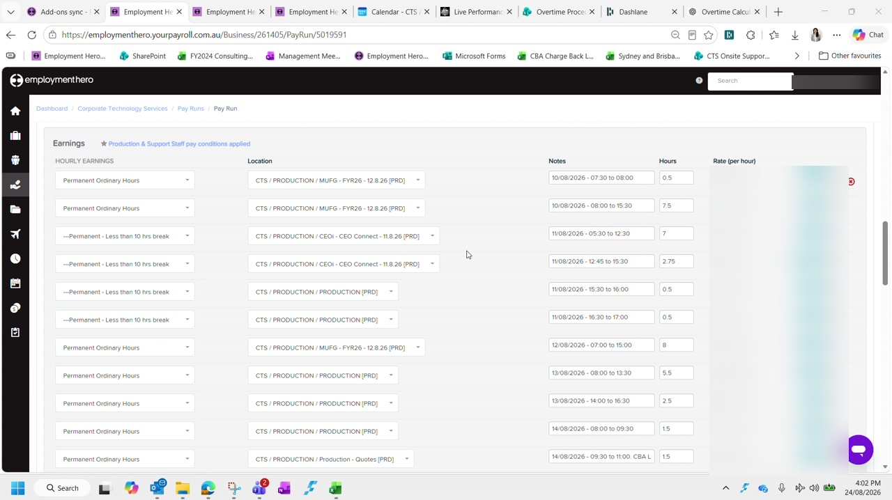
Figure 22 — Rows reclassified as 'Permanent - Less than 10 hrs break' sitting alongside normal 'Permanent Ordinary Hours'. Rates and amounts are blurred in this guide.
Salaried employees are not eligible. Because CTS pays above award, a salaried employee does not attract this overtime. The category applies a substantially higher hourly rate, so leaving it in place overpays them. These rows must be changed back to Permanent Ordinary Hours.

Check the employment type before acting. This correction applies to salaried employees — it is not a blanket rule for everyone the break condition flags.

Step 2 Copy the notes before you change anything
This is the step that catches people out, and there is no undo for it.
Changing the category wipes the notes. The moment you change the category on a row, Employment Hero overwrites whatever was in that row's Notes field. Copy the note text out first, change the category, then paste it back. If you change the category first, the note is gone and you will have to reconstruct it from the timesheet.

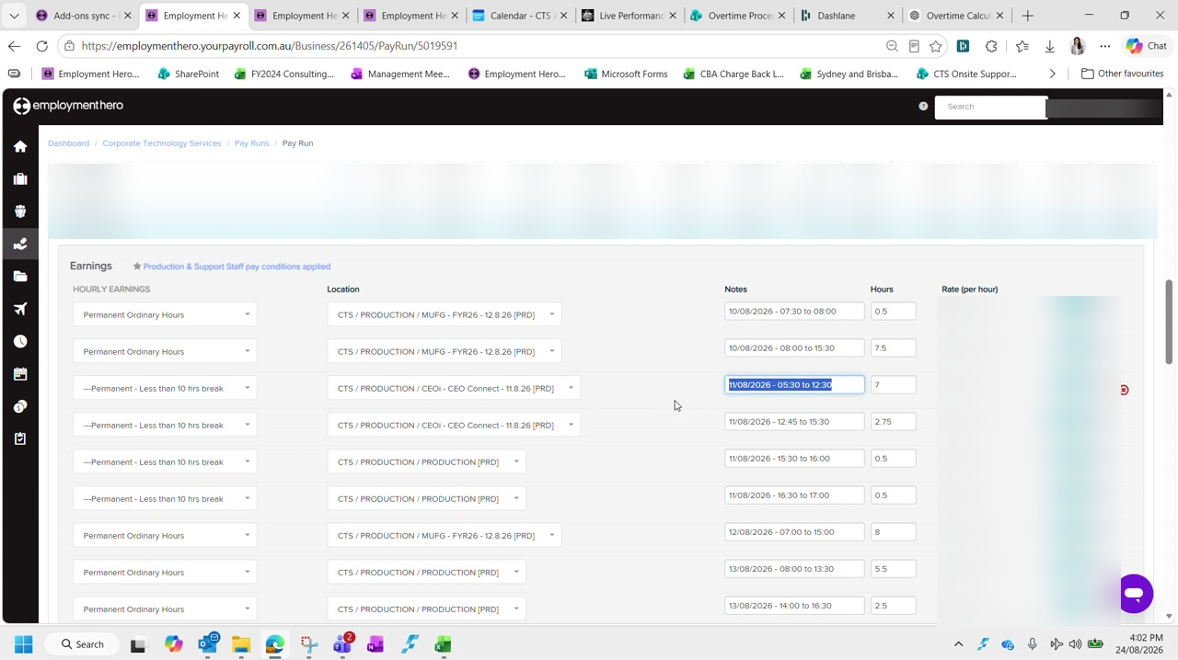
Figure 23 — Selecting the Notes text to copy before touching the category dropdown. Names, rates and amounts are blurred in this guide.
For each affected row, work in this order:
- Select and copy the contents of the Notes field
- Change the category dropdown to Permanent Ordinary Hours
- Paste the note back into the Notes field
- Confirm the hours on the row are still correct
Repeat for every row carrying the break category. In the example there were four.

Step 3 Re-check the total hours against the timesheets
Once the categories are corrected the employee's total will often sit below the expected 80 hours for a full-time fortnight. The reclassification changes how hours were captured, so they need checking against the source.
Open the employee's timesheets for the period and work through the days that are actually longer than eight hours — those are where the discrepancies sit.
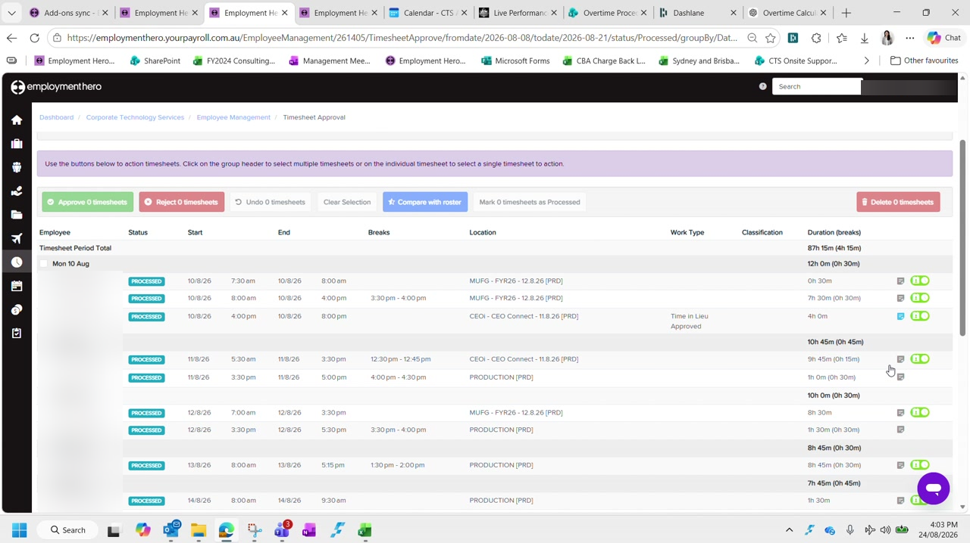
Figure 24 — Timesheet Approval showing each day's real duration, including breaks. The employee name is blurred in this guide.
Compare each of those days against what the pay run captured, and correct the hours where they differ. In the example the pay run had captured eight hours for 12 August where the timesheet showed ten, and two later days were each short by an hour or more.
Work to the expected total. Keep correcting until the total reaches the hours the employee is contracted for across the fortnight — 80 for a full-time employee. If you cannot reconcile to that figure, stop and investigate rather than adjusting a number to make it balance.

Step 4 Confirm the corrected total and check leave
With the categories fixed and the hours corrected, the employee's line should show the expected total and every row should sit on the ordinary hours rate.
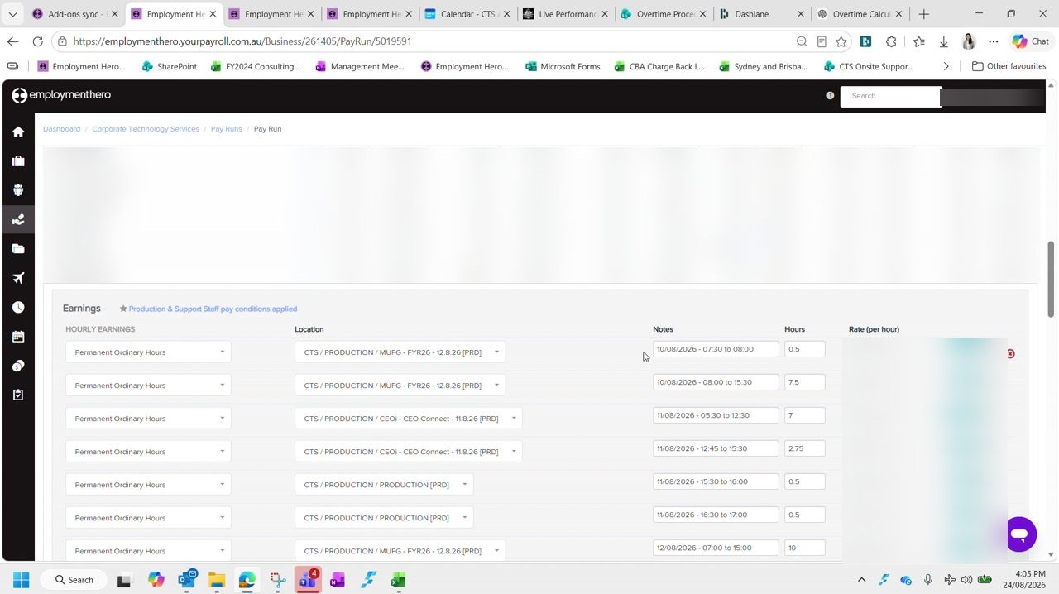
Figure 25 — The same employee after correction: 80 hours, all rows on Permanent Ordinary Hours. Names, rates and amounts are blurred in this guide.
Then check whether any leave was taken during the period, and populate the spreadsheet if so.
Leave taken, not leave accrued. These are different things and only one matters here. Leave accrued is what the employee earned over the period and needs no action. Leave taken is what they actually used, and that does need populating. In the example there was leave accrued but none taken, so no entry was required.

Step 5 Check pay run inclusions
Finally, check the employee's pay run inclusion settings for any standing arrangements — most commonly a superannuation salary sacrifice.
These carry nominated start and end dates, and they must match what the employee set out on their nominated form. In the example the sacrifice ran from 15 June through to the end of the financial year.
Check the dates, not just the amount. A salary sacrifice that has passed its nominated end date but is still active will keep deducting. Confirm the arrangement is still within its nominated period for the fortnight you are processing.

Checklist
For each employee flagged with an out-of-the-ordinary condition:
- The employment type has been confirmed before applying any correction
- Notes were copied before any category was changed, and pasted back afterwards
- Every incorrectly triggered row has been returned to Permanent Ordinary Hours
- Total hours reconcile to the employee's contracted hours for the fortnight
- Any leave taken during the period has been populated in the spreadsheet
- Pay run inclusions are active only within their nominated dates

Continues in: Part 5 — Reconciling & Balancing the Pay Run.

Part 5 — Reconciling & Balancing the Pay Run
Corporate Technology Services · Employment Hero Payroll · Fortnightly cycle

About this guide
By this stage every employee's hours have been reconciled through Parts 3a to 4. This guide covers everything that remains before the pay run can be finalised: applying the payroll notes, accruing bonus leave, verifying pay rates, and balancing the pay run against the spreadsheet.
Work through it in order. Balancing comes last for a reason — every earlier step changes the numbers you are balancing to.
Do not skip to balancing. It is tempting to check the totals early. Applying a single back pay afterwards throws the balance out again, so you will only have to redo it. Get everything in first, then balance once.

Step 1 Add anyone still missing from the pay run
Before applying adjustments, confirm everyone who should be paid is actually in the pay run. Employees who do not clock in will not be there, and neither will anyone recovering a shift from an earlier fortnight.
Part 3c covers both cases in full. Add them now, so that the totals you balance against are complete.

Step 2 Apply the payroll notes
The payroll notes collated back in Part 1 now get applied to the pay run. They fall into four kinds, each handled differently.

Back pay for an incorrect rate
Where someone was paid at the wrong rate in an earlier fortnight, do not calculate the difference by hand. Enter it as two lines and let Employment Hero do the arithmetic:
- Actions › Add earnings — enter the hours as a negative at the old, incorrect rate
- Actions › Add earnings again — enter the same hours as a positive at the correct rate
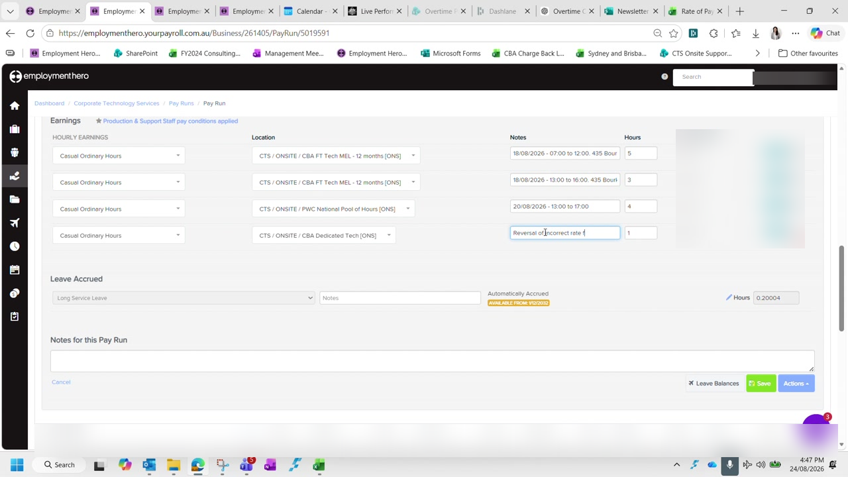
Figure 26 — Entering a rate reversal against an employee, with the reason recorded in the Notes field. Rates and amounts are blurred in this guide.
Write the reason in the notes on both lines, naming the fortnight being corrected. Then record the net difference in the back pay column of the spreadsheet.
The cost centre does not matter here. A rate reversal affects the dollar value, not where the cost lands. Pick a sensible cost centre and move on rather than working it out precisely.

Back pay for leave that was never captured
Where leave was approved but never made it into a pay run — usually because the approver did not click through the banner on the timesheet — the shifts may already exist in Employment Hero.
In that case use Import Timesheets, choose the unpaid timesheets option, and select only the dates being corrected. Delete every other row the import brings in, then check the employee's total afterwards.

Time in lieu adjustments
Time in lieu is adjusted through Actions, using Accrue leave to add and Adjust leave to remove. Label each entry with the reason, such as an incorrect accrual being reversed.
Untick the option that affects pay. When adjusting leave down, make sure the setting that applies the adjustment to the dollar value is unticked. Leaving it ticked deducts the value from the employee's pay as well as their balance, which is not what an accrual correction should do.

Per diem
Per diem is paid to employees travelling during the fortnight, and is normally paid before the travel date rather than after.
CTS rate | $75 per night — this is the rate to use
Award rate | Substantially lower and set per meal. CTS pays its own rate instead.
How to enter it | Use units multiplied by nights rather than a single combined figure

You will usually know about travel already. Travel is normally booked by you, so it will show on the credit card. The production manager will also flag team members travelling, and the shared calendar confirms it.

Step 3 Accrue bonus leave — last pay run of the month only
Bonus leave is accrued once a month, in the last pay run of that month, and always a month ahead. It is tracked manually in a separate spreadsheet, so nothing prompts you to do it.
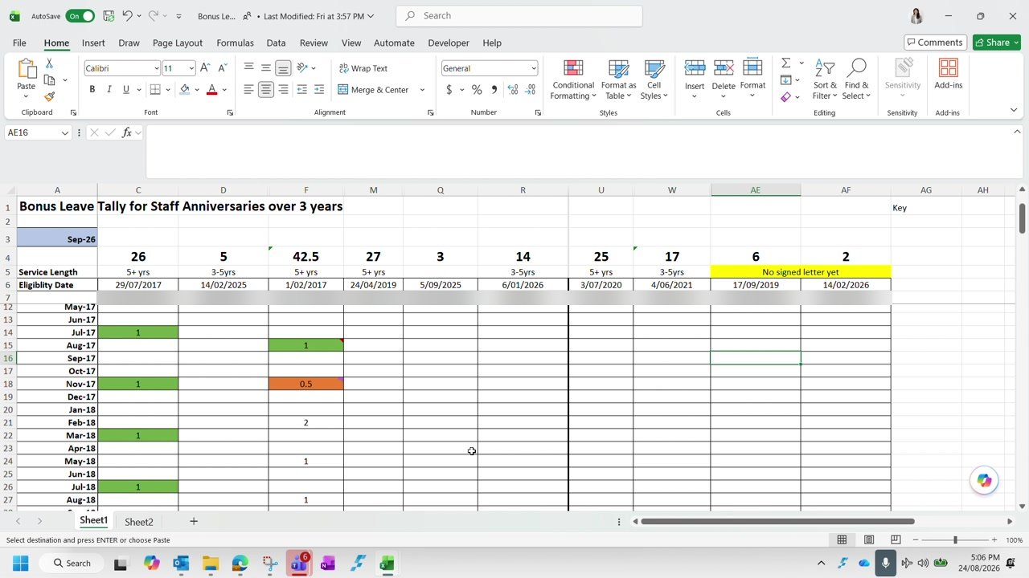
Figure 27 — The bonus leave tracker, listing staff anniversaries and the days accrued against each month. Employee names are blurred in this guide.
The tracker records service length and eligibility date for each employee, with a row per month. Entries are days, not hours. Read the colours as follows:
Green | The bonus leave has been used
No highlight | Accrued but not yet used
Yellow | The employee's anniversary date — a new entitlement year begins

For each employee with an entry against the coming month, use Actions › Accrue leave, choose the bonus leave category, and label it with the month and year. A day is eight hours.
No accrual without a signed letter. An employee is not accrued bonus leave until their letter has been issued and signed. Where a letter is outstanding, mark it on the tracker and leave the accrual — it can be backdated once the letter is in place.

Entitlement grows with service, so the tracker needs extending as people pass each milestone. Because it is maintained by hand, open it any time bonus leave is involved rather than assuming it is current.

Step 4 Verify pay rates
Before balancing, every pay rate in the spreadsheet needs checking against the rate increase spreadsheet. Anyone absent from that spreadsheet has had no change, so their existing rate stands.
For salaried employees the hourly rate is derived from the annual salary:
Formula | Annual salary ÷ 1.12 ÷ 52 ÷ 40
The ÷ 1.12 | Removes superannuation — the spreadsheet holds rates excluding super
Then ÷ 52 ÷ 40 | Converts the annual figure to an hourly rate, which is how Employment Hero calculates it

Check whether a quoted rate includes super or loading. Rates get quoted three ways — inclusive of super, inclusive of casual loading, or bare. The spreadsheet wants the rate excluding both. Most reconciliation errors at this step come from comparing two figures that are not on the same basis.

Some rates do not flow through from HR. A known Employment Hero fault means a rate updated in HR sometimes fails to reach payroll, leaving the old rate in place — often flagged with a warning icon on the employee. Override the rate manually for the current pay run, and check whether earlier fortnights were underpaid. If they were, that is a back pay to add under Step 2.

Mark each rate green once verified. Colour anything you could not verify differently so it is picked up next fortnight rather than being assumed correct.

Step 5 Balance the pay run
Balancing compares the spreadsheet against Employment Hero on two figures: total hours and total dollar value. The spreadsheet carries a checksum row that does the comparison for you.
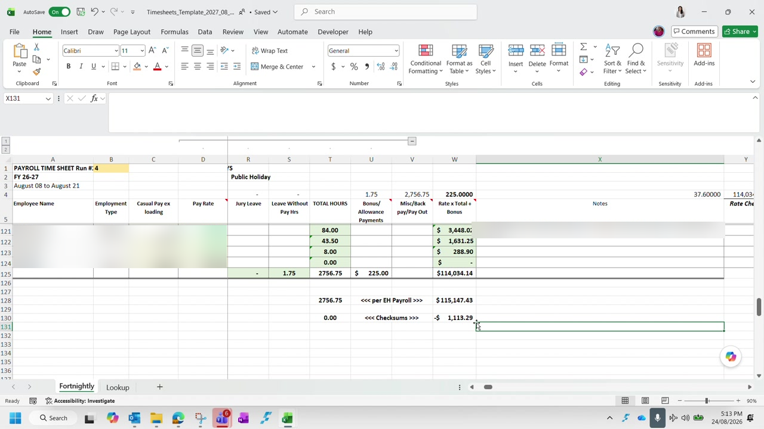
Figure 28 — The checksum rows at the foot of the timesheet spreadsheet. Hours agree at zero while the dollar value is still out. Names and rates are blurred in this guide.
Enter the Employment Hero figures against the per EH Payroll row and read the checksums beneath:
Hours checksum at 0.00 | Total hours agree — the reconciliation work in Parts 3a to 4 is complete
Dollar checksum not zero | Hours are right but a rate or multiplier is wrong somewhere

Hours almost always balance first, because that is what the earlier parts were reconciling. A dollar variance with balanced hours means the hours are in the right place but at least one is being paid at the wrong rate.
To find it, read gross earnings employee by employee from the spreadsheet against the pay run. It is tedious but reliable, and the variance is usually a single employee. Filtering out rows already agreeing narrows it quickly.
An overtime rate is the usual culprit. When hours balance but dollars do not, check overtime rates before ordinary rates. An overtime multiplier applied to a stale base rate produces a small variance that is easy to overlook and hard to spot in the totals.

Work the variance down to zero. A residual of a cent or two from rounding is acceptable; anything larger has a cause worth finding.

Checklist
The pay run is ready to finalise when:
- Everyone who should be paid is in the pay run, including those who do not clock in
- Every payroll note has been applied — back pays, leave corrections, time in lieu adjustments and per diem
- Bonus leave has been accrued, if this is the last pay run of the month
- Every pay rate has been verified and marked, with unverified rates flagged
- Rates that failed to sync from HR have been overridden and any resulting back pay added
- The hours checksum reads zero
- The dollar checksum reads zero, or within a couple of cents of rounding

Continues in: Part 6 — Finalisation & Bank Upload.

Part 6 — Finalisation & Bank Upload
Corporate Technology Services · Employment Hero, CommBiz · Fortnightly cycle

About this guide
This is the final stage of the fortnightly cycle. By this point the hours and dollar values are reconciled and every payroll note is captured in the pay run. What remains is to finalise, pay, and file the records.
It is the longest stage and the least reversible. Read Step 1 before you click anything.
Finalising is close to a one-way door. Once super payments have been made against a pay run, Employment Hero will not let you unlock it. Corrections after that point are far harder than corrections before it. Be confident the reconciliation is complete.

Step 1 Finalise the pay run
In the pay run, check the header details once more — pay period and paid date — then click Finalise Pay Run. Set the approver to Graham and confirm.
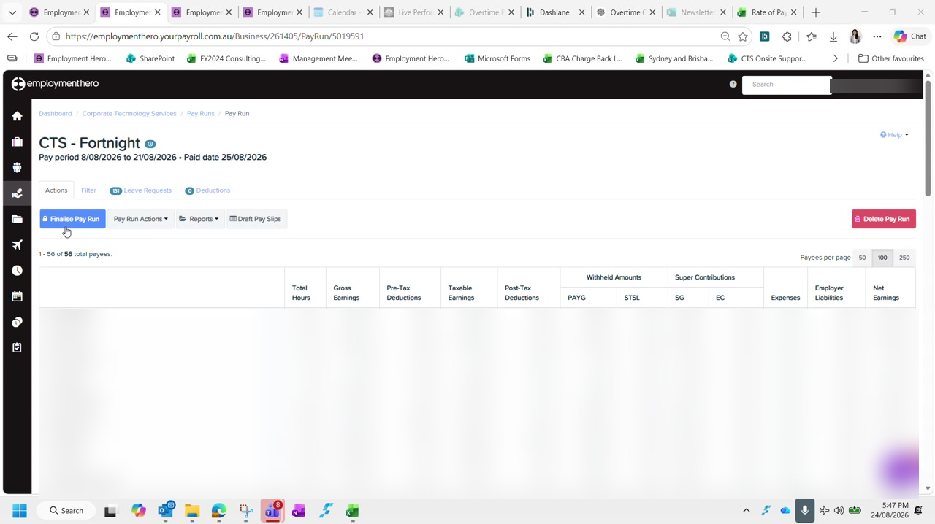
Figure 29 — The pay run before finalisation. Employee rows are blurred in this guide.
Finalising requires a second person to approve. They log in, review the total, and approve. Nothing further can happen until they do.
Once approved, refresh the page. The payment file and the reports only become available after the refresh.

Step 2 Download the ABA file and upload it to CommBiz
The ABA file is the payment instruction the bank reads. Download it from the pay run, then upload it to CommBiz.
In CommBiz, go to Payables › Import › Import Files and complete the form:
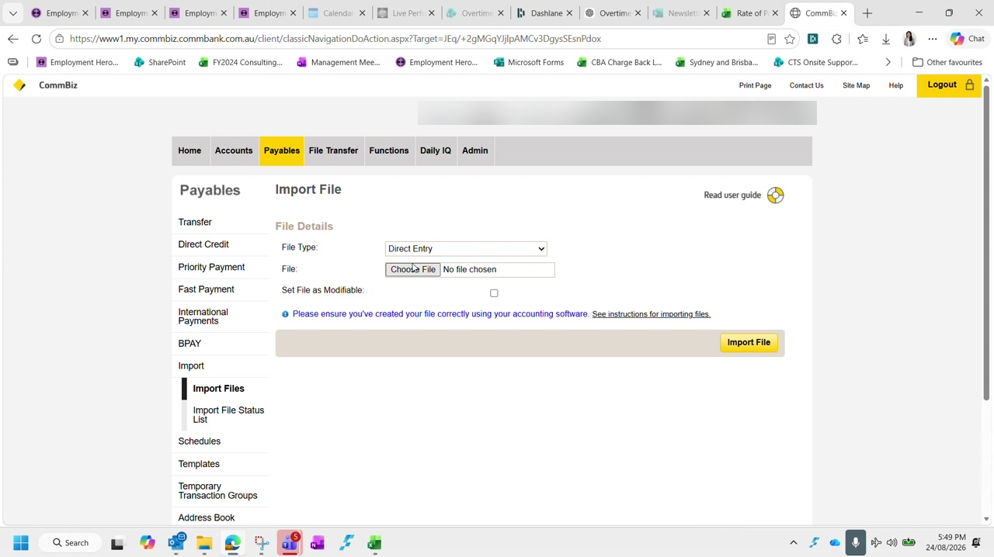
Figure 30 — The CommBiz Import File screen. Account and user identifiers are blurred in this guide.
File Type | Direct Entry
File | The ABA file you just downloaded
Set File as Modifiable | Tick it — it costs nothing and leaves room to correct the file if needed

Click Import File. To see the imported file you need to click through the confirmation and then back out — it does not appear immediately. Check the total on the confirmation screen matches the pay run, then Submit, Confirm, and OK.

Step 3 Check there are enough funds — including super
The payment is now sitting in CommBiz awaiting approval, so the account needs to cover it. This is the step where the numbers look confusing, so it is worth understanding why they differ.
Gross earnings is not what leaves the account. Gross earnings is the pre-tax figure and excludes super and PAYG. What actually gets paid is the net amount in the ABA file, plus other expenses such as staff expenses captured in the float line. That is why the transfer figure and the payroll figure never match.

Work out the total you need to cover:
- The net payroll amount in the ABA file
- Superannuation, which is direct debited separately and at the same time
- Any other payments due to leave the account in the next day or two — check for scheduled items such as a BAS payment
Confirm whether those other payments have already been taken before allowing for them, or you will transfer more than you need.
Leave a 20K buffer. Transfer enough to cover payroll and super and still leave roughly $20,000 in the account. To see what is coming, run the transaction group list across the payroll dates — from the day before the pay date through to the pay date itself.

Make the transfer from the savings account. Use a description that will still make sense when it flows through to Xero — 'MT payroll' works, where MT is money transfer. The wording is free text, but it should be recognisable later.

Step 4 Notify the approver
The payment will not go anywhere until Duncan approves it in CommBiz, so tell him it is waiting. This happens two ways, and both are needed.
Send the payroll email to Duncan, copying Graham, Danica and accounts. Use a subject naming the fortnight ending date. Attach the production summary and anything else relevant to the fortnight, along with a screenshot of the transaction group list.
Then post in the payments chat, tagging Duncan, to say payroll is in CommBiz for approval and note the payroll notes reference.

Step 5 Process super
From the finalised pay run, click Create Super Payment. Super is direct debited automatically, so there is nothing to pay in CommBiz for it.
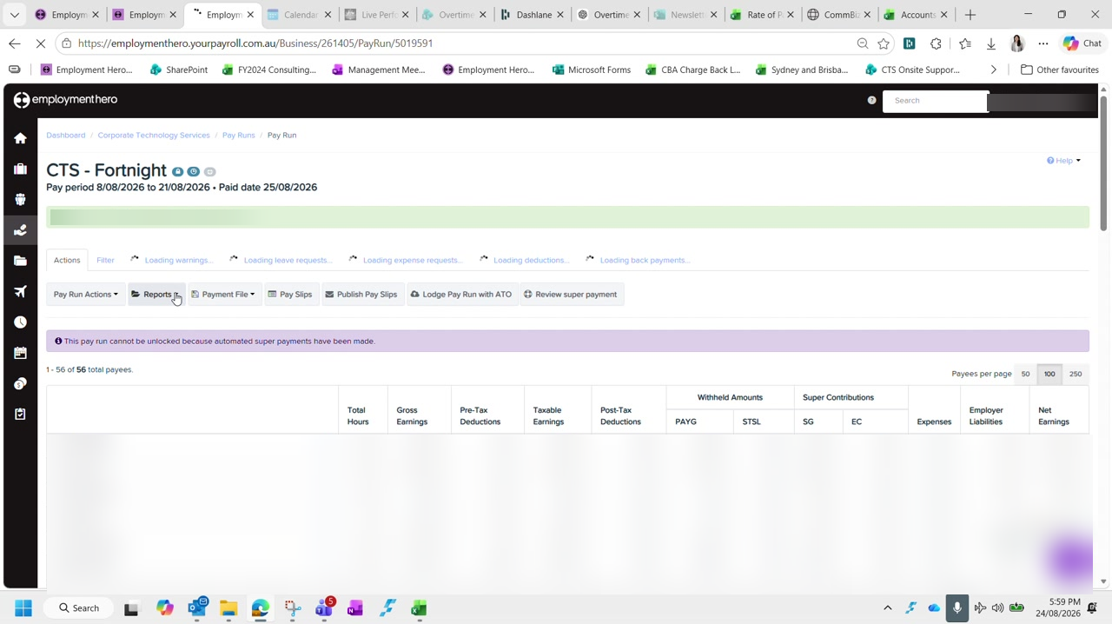
Figure 31 — The finalised pay run and the actions available afterwards. Approver name and employee rows are blurred in this guide.
Creating the batch does not send it. Creating a super batch does not submit anything to the clearing house — you still have to validate and confirm it separately. If you create one by mistake you can delete it. Once the batch exists the button changes to Review Super Payment, which is how you can tell it worked even if the screen appears not to have loaded.

Employment Hero can be slow here and gives little indication it is working. If it will not load at all, super can be processed the following day — it does not have to happen in the same sitting as the pay run.

Step 6 Download and file the reports
Five files need saving for every fortnight. The first two come from the pay run itself; the last two come from the Reports menu rather than the pay run.
Pay slips | Pay run › Download Pay Slips for printing
Pay run audit | Pay run › Reports › Audit report — tick everything on the left, Run report, download as Excel
ABA file | The payment file downloaded in Step 2
Leave balances | Reports › Leave Balances — run to the pay period end date, Excel
Leave liability | Reports › Leave Liability — run to the pay period end date, Excel

Set both leave reports to the pay period ending date, not today's date.
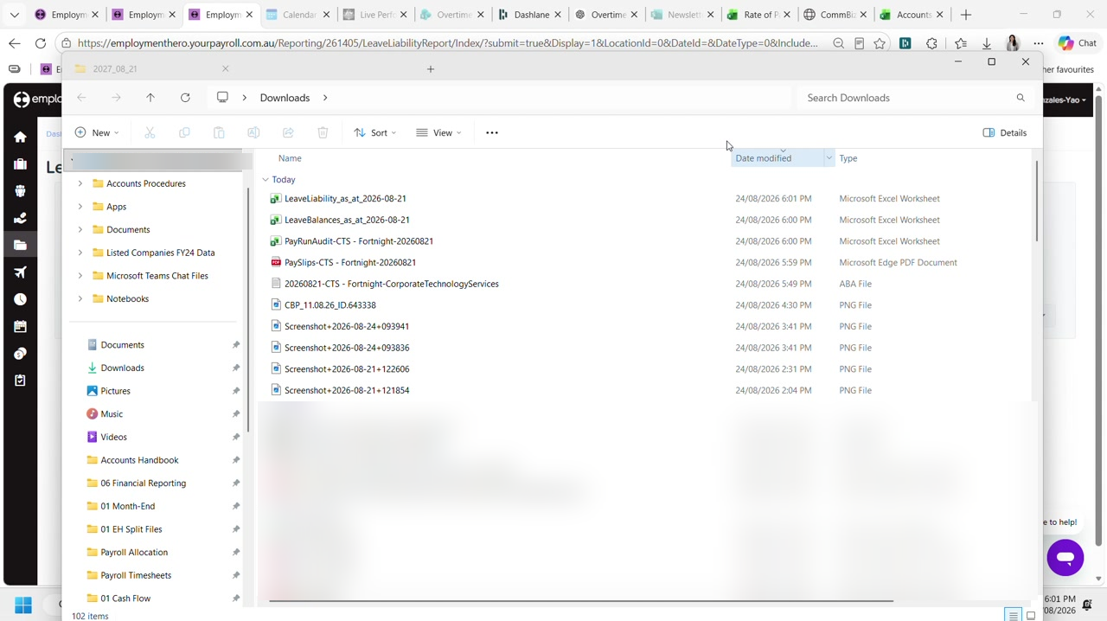
Figure 32 — The five payroll files downloaded for the fortnight. Unrelated files are blurred in this guide.
Move all five out of Downloads and into the folder for the corresponding fortnight, together with any emails relating to the period.
File everything for the fortnight together. Anything relating to the fortnight — the bank file, the reports, the emails behind an adjustment — belongs in that fortnight's folder. It costs a moment now and saves a great deal when someone queries a pay six months later.

Step 7 Publish pay slips the next day
Do not publish pay slips yet. Employees are notified the moment you do, so this waits until the payment is actually approved.
The following day, once you know Duncan has approved the payment in CommBiz, go back into the pay run and click Publish Pay Slips. That is what notifies employees.
Still outstanding after this stage. Lodging the pay run with the ATO is a separate action from the finalised pay run screen, and can also be done the following day alongside super if Employment Hero is unavailable.

Checklist
The fortnight is complete when all of the following are true:
- The pay run is finalised and approved
- The ABA file is imported into CommBiz and submitted
- Funds cover net payroll, super and any other scheduled payments, with a 20K buffer remaining
- The payroll email has gone to Duncan, copying Graham, Danica and accounts
- Duncan has been tagged in the payments chat
- The super payment batch has been created, validated and confirmed
- All five reports are saved into the fortnight folder, along with related emails
- Pay slips published the following day, after the payment is approved
- The pay run has been lodged with the ATO

Continues in: This completes the fortnightly payroll cycle. The next fortnight begins again at Part 1 — Payroll Prep.

